Will Kelsey, Nick Krysko

Assignment 4 Use Case Model

UML models are beneficial for organizing code and later programs. Its benefits are more apparent before coding even begins. It provides a visual path for the end result, allowing developers split up tasks and create modules that add up to the completed system. Creating use case models displays each possible action a user could take and outlines the possible paths. For CURSE, the user model distinguishes the differences between each user. For instance, the admin has the greatest view capabilities, effectively identical to both the student and instructor plus more granular and unrestricted controls. The admin manages the server system through several tasks, the largest being “modify courses”.

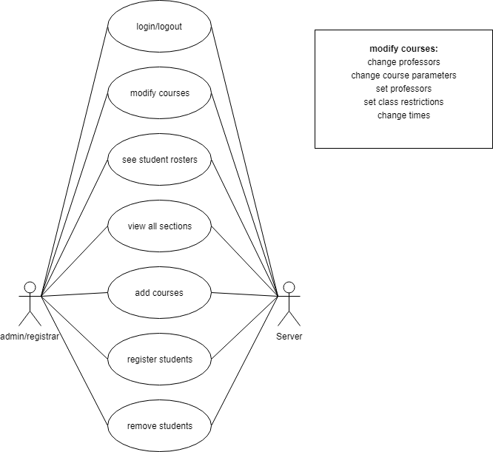 Modify courses gives the admin the ability to change all attributes of a course. It can set the instructor, set the time for the course, and set specific restrictions for students. Ultimately this is one part of many. Most students will need to be registered in some form of course or removed from the institution for not registering. There can either be an override for the admin to add a student to a course, or remove students who are in too many. This power is available to that student as well, in the form of registration and withdrawing.

See Student Use Case Model.

See Instructor Use case Model.